**Easy:**

Basic Prompt: write a code in python for arithmetic operators excluding division

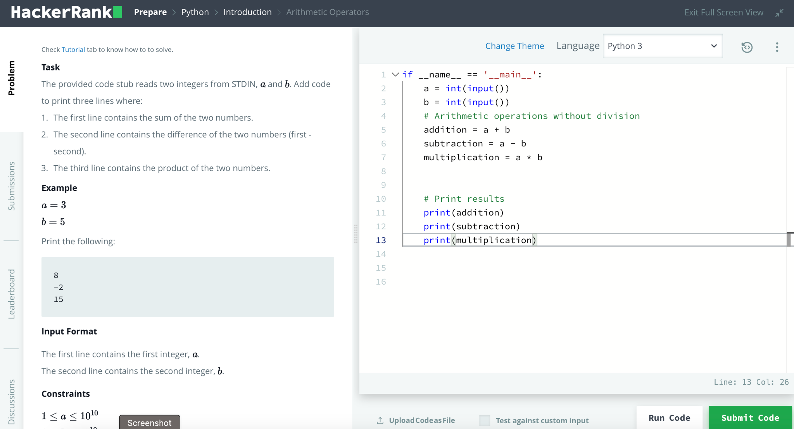

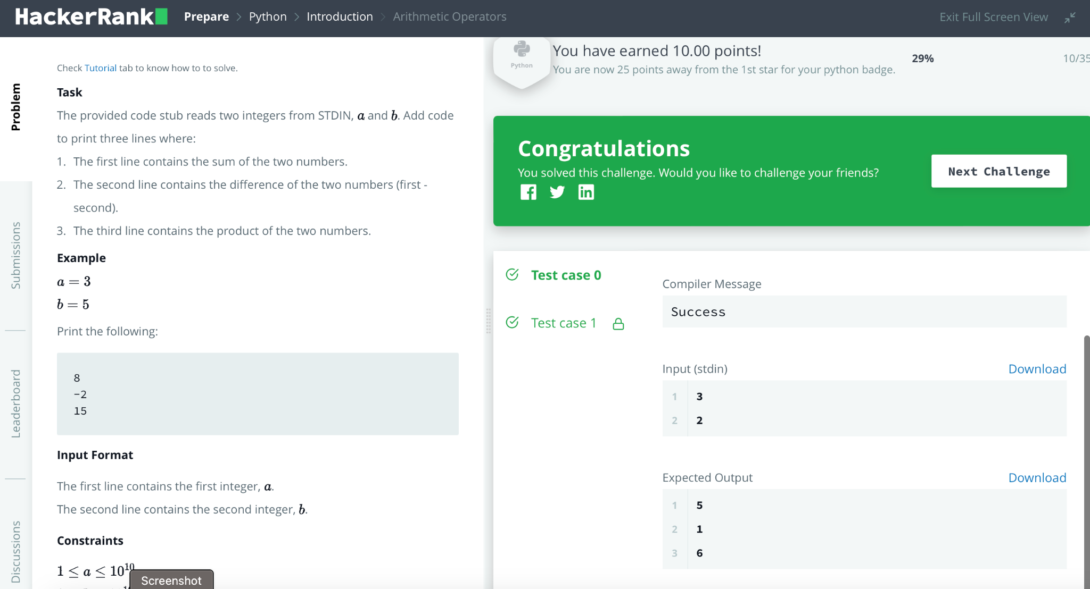

Second Prompt Engineering technique :

The prompt for this code is to perform arithmetic operations (addition, subtraction, and multiplication) on two input integers and print the results. The inputs are taken from the user and stored as variables 'a' and 'b'.

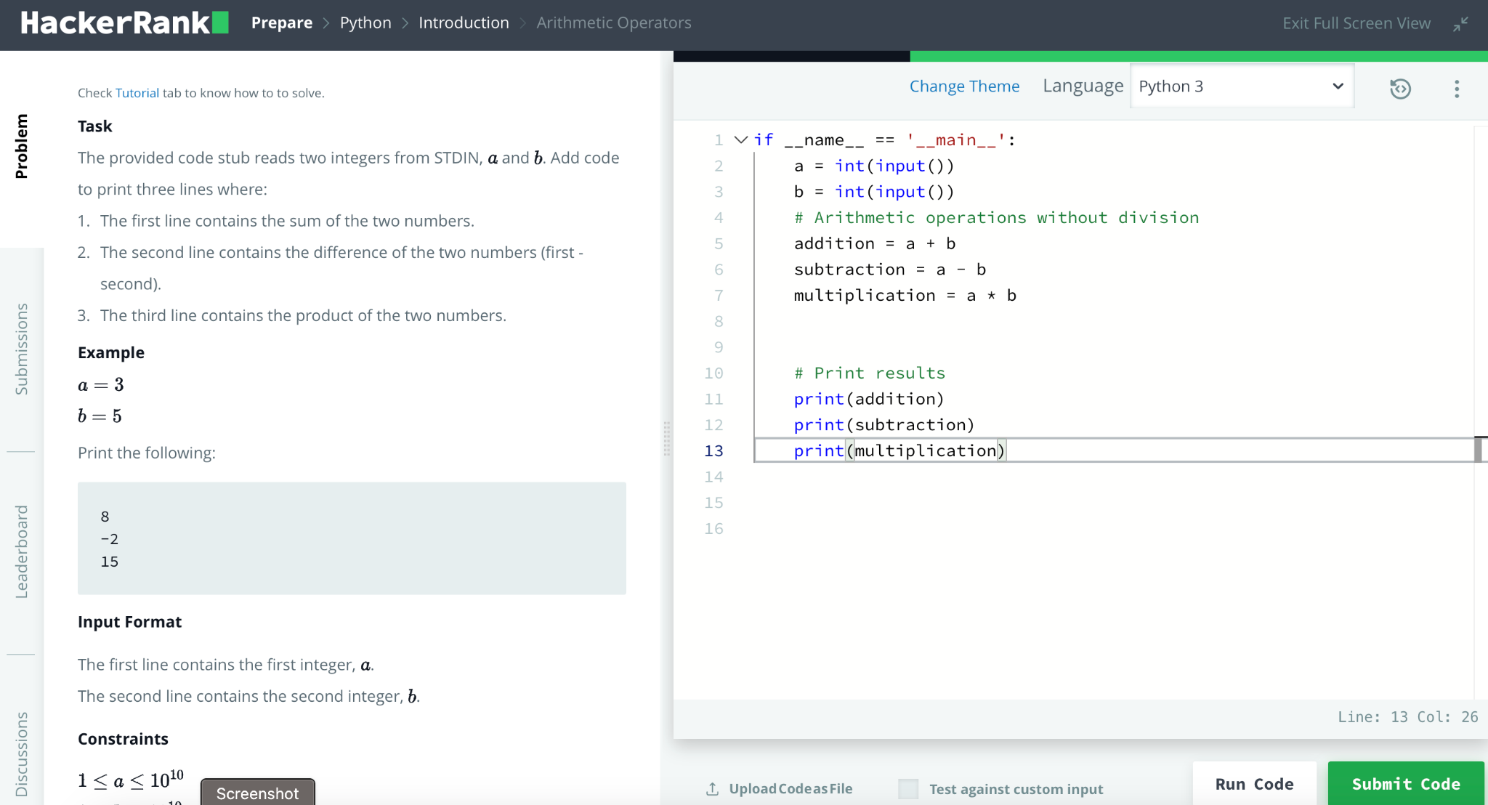

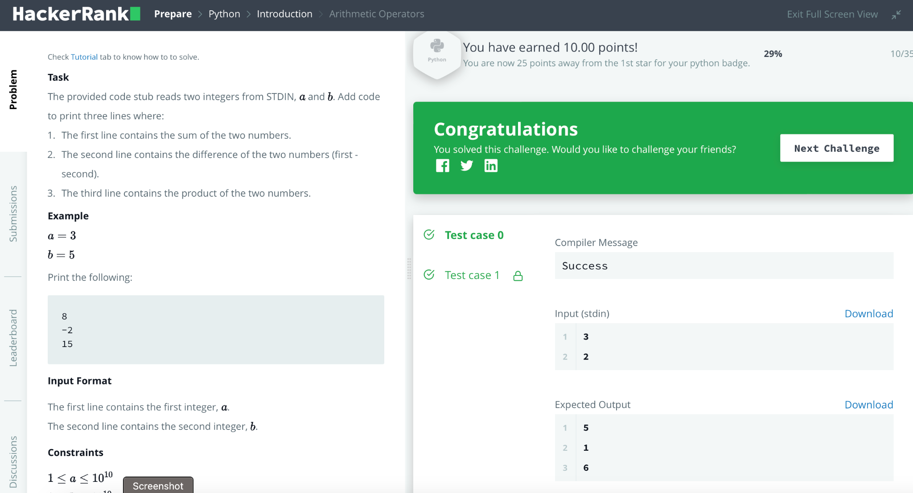

**Medium :**

Basic Prompt: Given a string "word", the task is to compress the string by grouping consecutive identical characters and representing them as a tuple of two elements, the first being the number of consecutive occurrences of that character, and the second being the character itself. The output should be a list of tuples, each representing a group of consecutive identical characters.

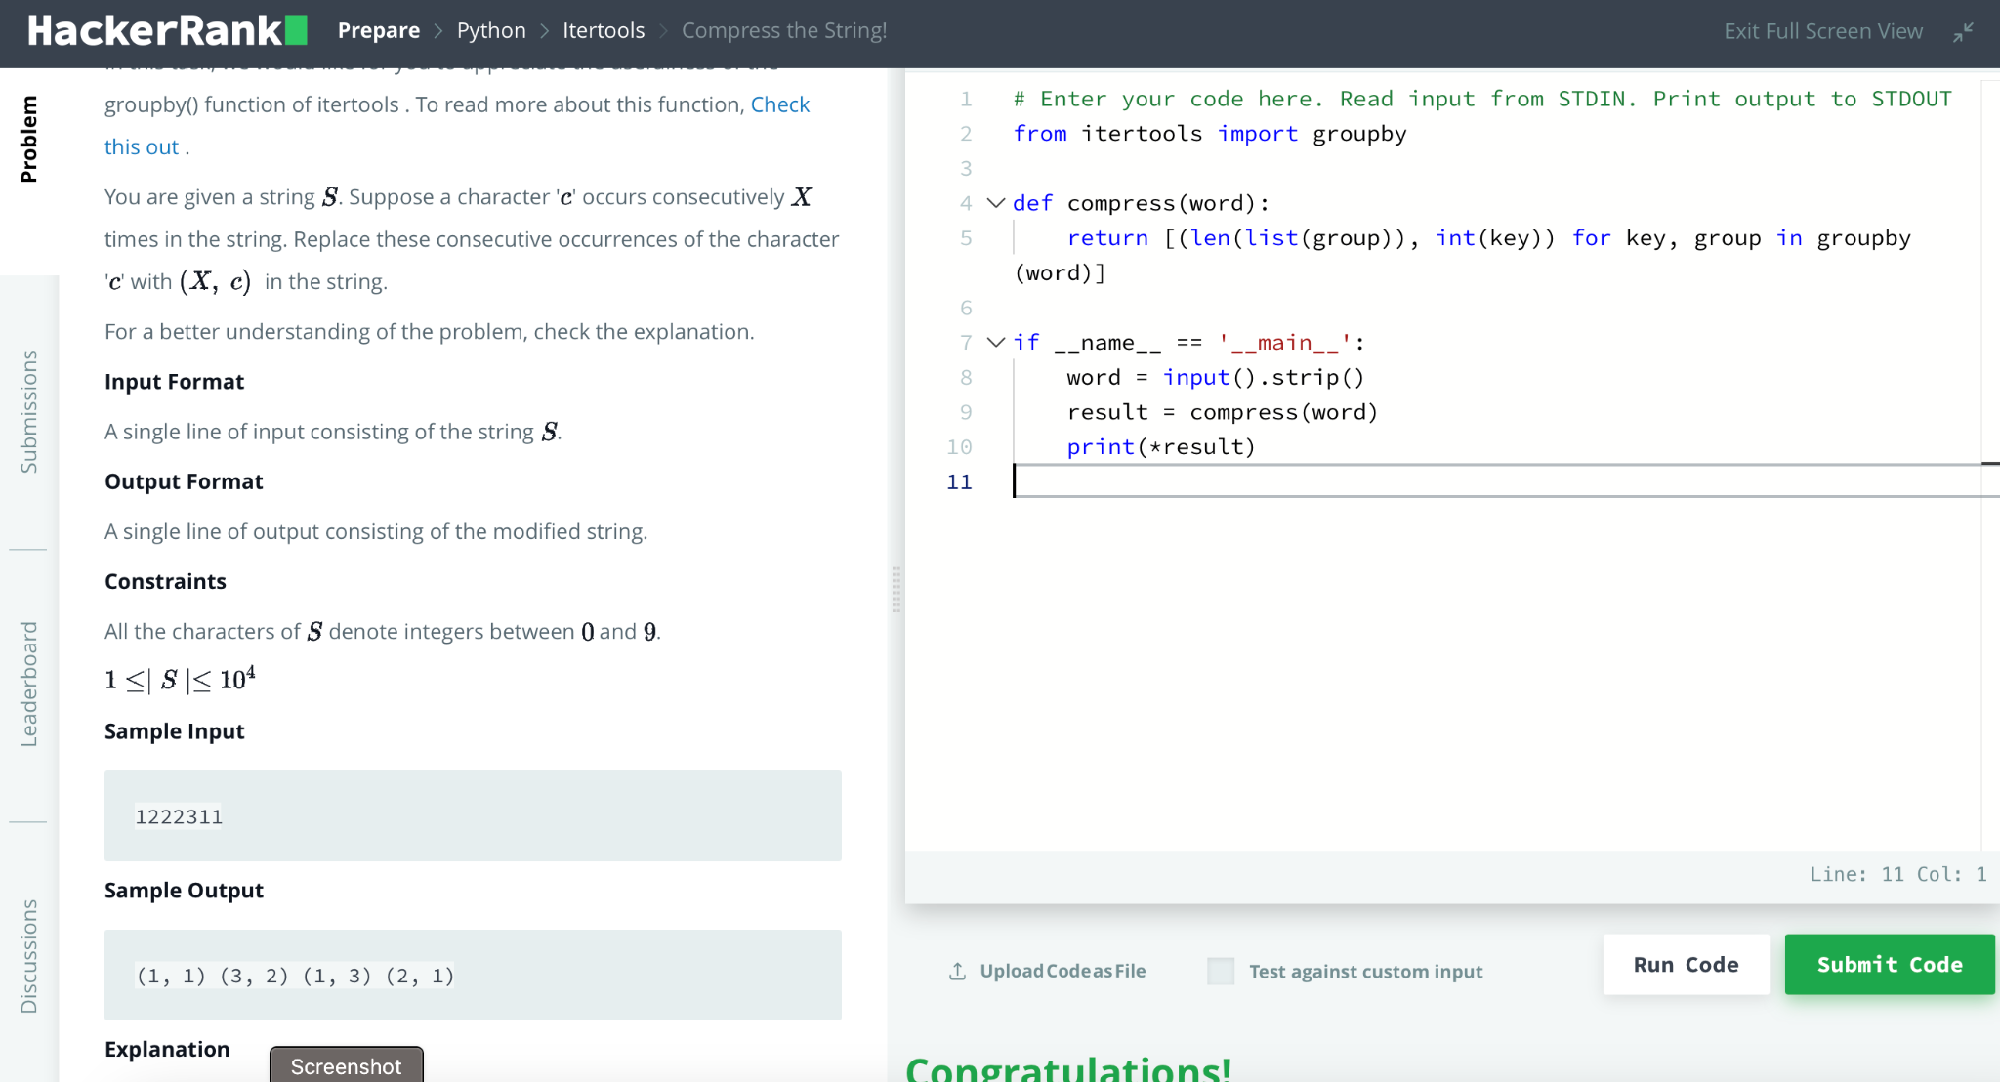

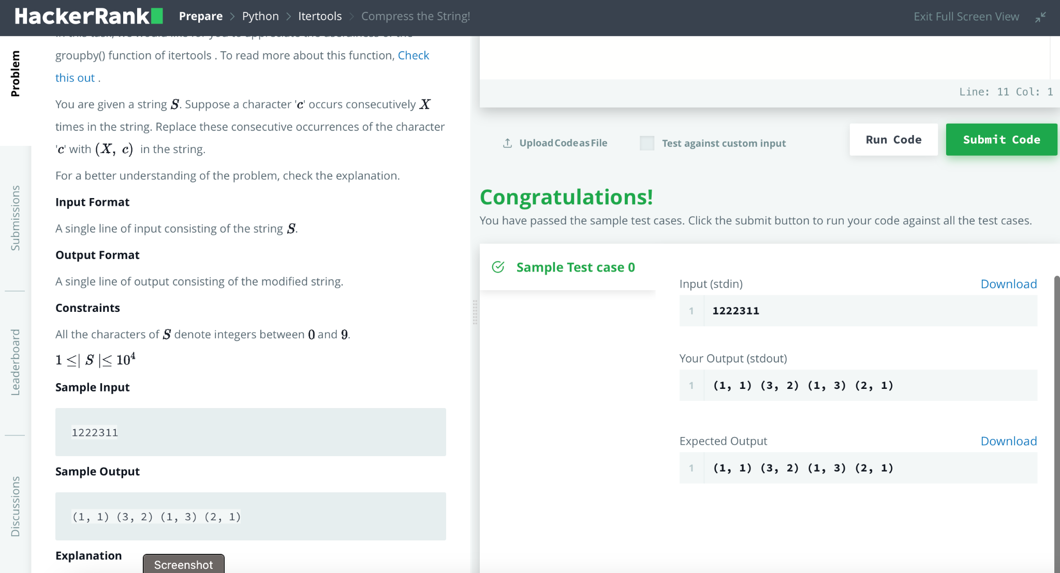

Second Prompt Engineering technique:

Write a code Given a string "word", the task is to compress the string by grouping consecutive identical characters and representing them as a tuple of two elements, the first being the number of consecutive occurrences of that character, and the second being the character itself. The output should be a list of tuples, each representing a group of consecutive identical characters. Here All the characters of the "word" denote integers between 0 and 9 and the "word" lies between 1 and 10,000.

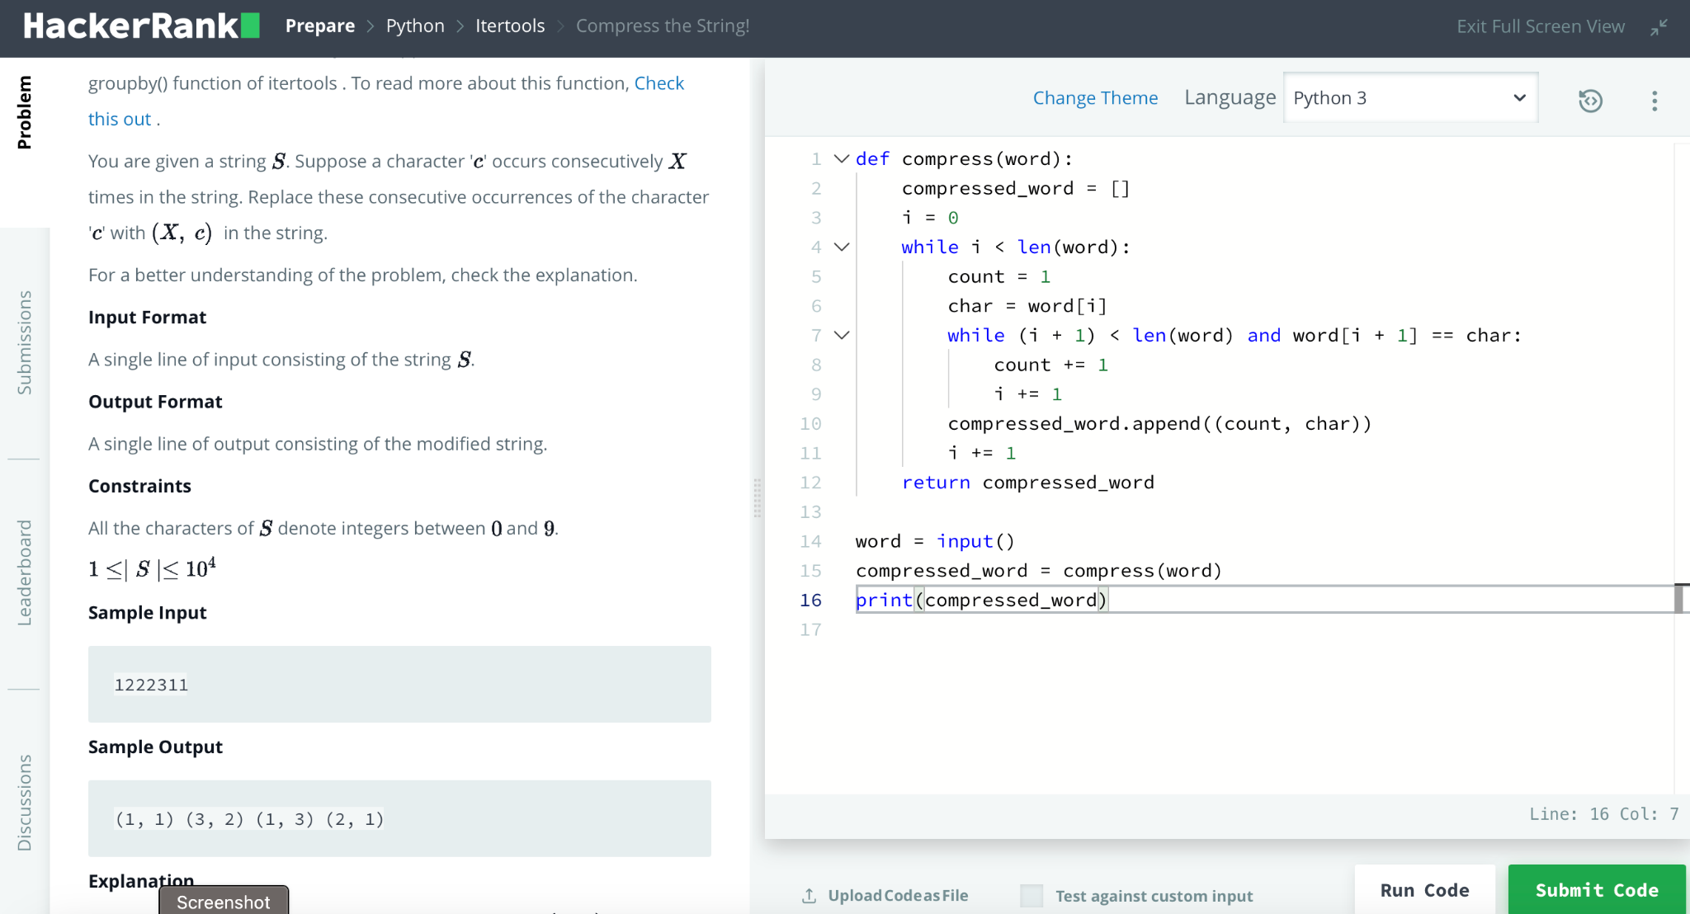



**Hard:**

Basic Prompt : Given, f(x) = x2. You are also given k lists. The list consists of Ni elements. You have to pick one element from each list so that the value from the equation below is maximized:

S = (f(x1) + f(x2) + .... + f(xk)) % M

Note that you need to take exactly one element from each list, not necessarily the largest element. You add the squares of the chosen elements and perform the modulo operation. The maximum value that you can obtain, will be the answer to the problem.

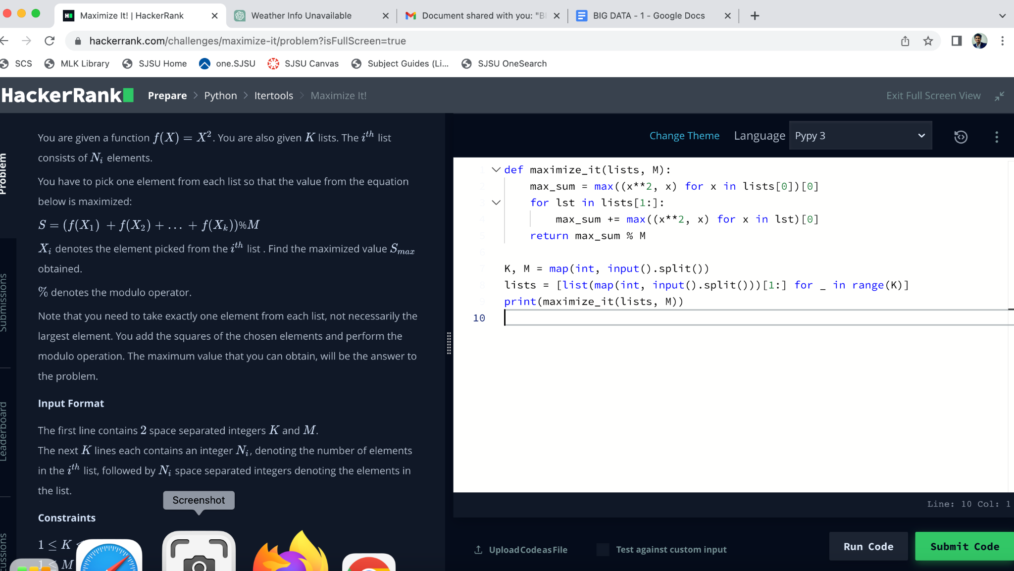

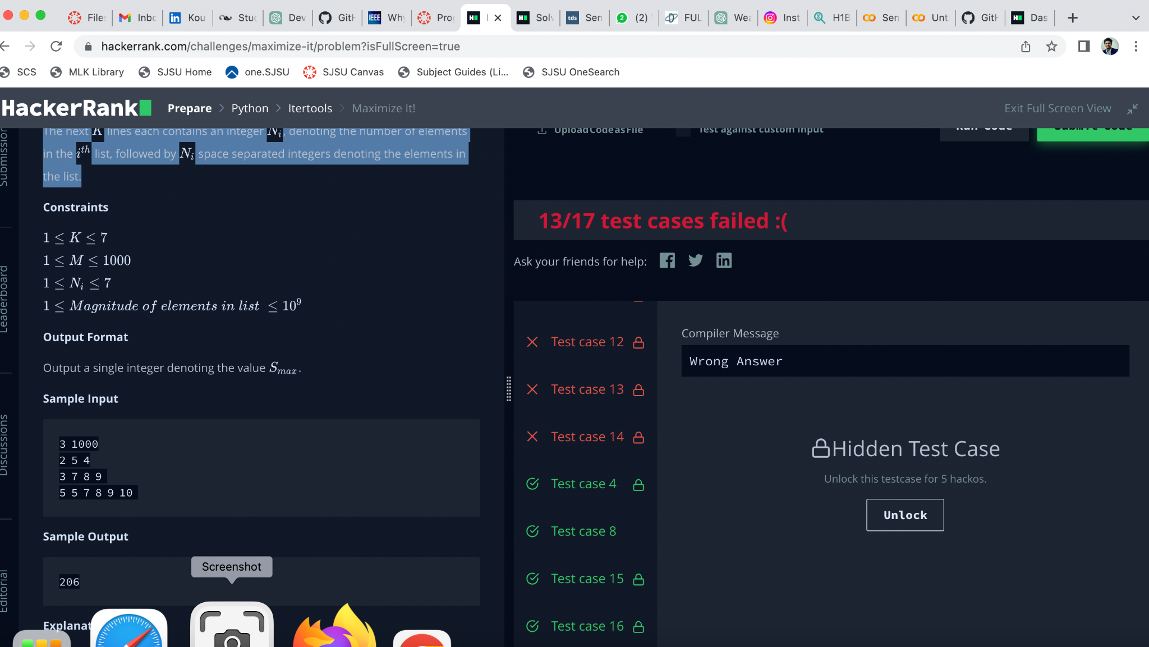

Second Prompt: Improve this solution by using tuples

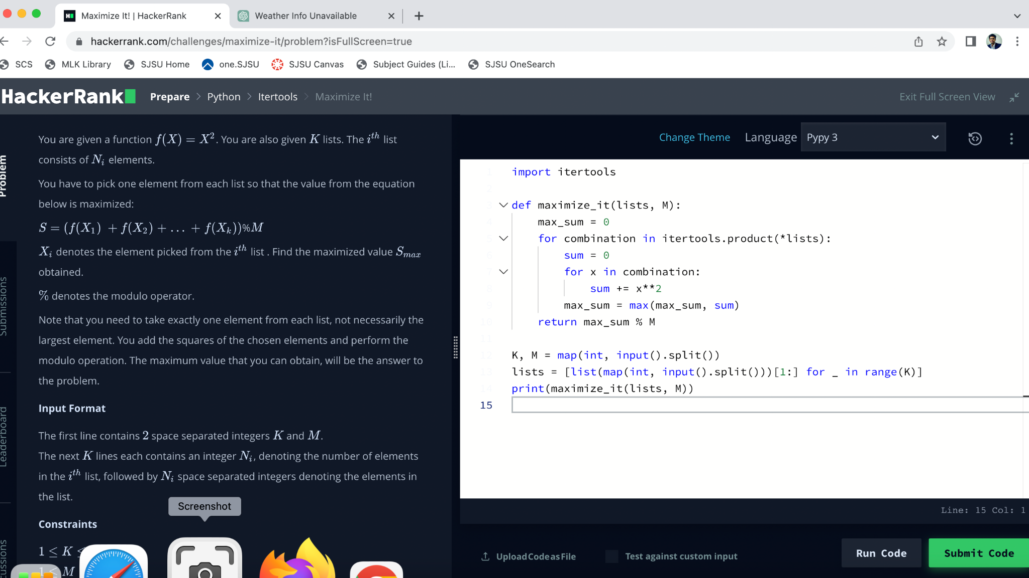



Third Prompt : Use itertools and optimize solution

